A Project Report

on

**RENT & GO**

**Technical Skilling - III**

A project report submitted in partial fulfillment of the requirements for the degree of Bachelor of Technology in Computer Science and Engineering

by

**VIDIYALA ABHIRAM (2010030180)**

**TAHSHEEN BEGUM (2010030168)**

**ALWALA RAGHAVENDRA GOUD (2010030394)**

**ROKKAM VIVEVEK VARDHAN REDDY (2010030142)**

Under the guidance of Under the guidance of

**NAME OF THE GUIDE NAME OF THE GUIDE**

Designation Designation



**Name of the University**

**DEPARTMENT OF COMPUTER SCIENCE AND ENGINEERING**

(Full Address of the Institution)



**NAME OF THE UNIVERSITY**

(Full Address of the Institution)

**DEPARTMENT OF COMPUTER SCIENCE AND ENGINEERING**

**CERTIFICATE**

This is to certify that the Project work entitled “**RENT & GO**” is carried out by  **VIDIYALA ABHIRAM (2010030180) TAHSHEEN BEGUM (2010030168) ALWALA RAGHAVENDRA GOUD (2010030394) ROKKAM VIVEVEK VARDHAN REDDY(2010030142)** in partial fulfillment for the award of degree of **Bachelor of Technology** in **Computer Science and Engineering**, Name of the University, Full address of the University during the academic year 20XX-20XX.

XXXXXXXX XXXXXXXXXX

Internal Guide Internal Guide

Signature of the HOD External Examiner

(Certificate from Industry)

## DECLARATION

I hereby declare that the project titled “RENT & GO” submitted to COMPUTER SCIENCE AND ENGINEERING, KL UNIVERSITY, HYDERABAD for the award of the degree of Bachelor of Technology in Computer Science and Engineering is a result of original work carried-out in this project report. I understand that my report may be made electronically available to the public. It is further declared that the project report or any part thereof has not been previously submitted to any University or Institute for the award of degree or diploma.

Name of Student(s) :

Hall Ticket Number(s):

Degree : Bachelor of Technology in COMPUTER SCIENCE AND ENGINEERING

Department : **Computer Science and Engineering**

Title of the project : RENT & GO

_________________________________

(Names’ of the Students’)

Date:

## ACKNOWLEDGEMENT

First and foremost, we thank the lord almighty for all his grace & mercy showered upon us, for completing this project successfully.

We take grateful opportunity to thank our beloved Founder and Chairman who has given constant encouragement during our course and motivated us to do this project. We are grateful to our Principal **Dr. L. Koteswara Rao** who has been constantly bearing the torch for all the curricular activities undertaken by us.

We pay our grateful acknowledgement & sincere thanks to our Head of the Department **Dr. Chiranjeevi Manike** for his exemplary guidance, monitoring and constant encouragement throughout the course of the project.

We thank **Project Supervisor(s)** of our department who has supported throughout this project holding a position of supervisor.

We whole heartedly thank all the teaching and non-teaching staff of our department without whom we won’t have made this project a reality. We would like to extend our sincere thanks especially to our parents, our family members and friends who have supported us to make this project a grand success.

_______________________

V.ABHIRAM (2010030180)

_______________________

TAHSHEEN BEGUM (2010030168)

_______________________

ALWALA RAGHAVENDRA GOUD (2010030394)

_______________________

ROKKAM VIVEK VARDHAN REDDY (2010030142)

## ABSTRACT

This project is being considered in order to reduce and eliminate loss of customers to competitors, and save the company from folding up. The current system is manual and it is time consuming. It is also cost ineffective, and average return is low and diminishing. Currently, customers can call or walk-in in order to rent or reserve a vehicle. The staff of the company will check their file to see which vehicle is available for rental. The current system is error prone and customers are dissatisfied. The goal of this project is to automate vehicle rental and reservation so that customers do not need to walk-in or call in order to reserve a vehicle. They can go online and reserve any kind of vehicle they want from the inventory of available vehicles. Even when a customer chooses to walk-in, computers are available for him to go online and perform his reservation. When he choose to reserve by phone, any of the customer service representatives can help him reserve the vehicle speedily and issue him a reservation number. The project will maintain the database of all vehicles the company has. It will also keep track of all vehicle reservation and return. Reports will be generated bi-weekly. Reports for the Accounts Manager will detail the cost incurred to maintain each vehicle and revenue accrued on each vehicle.

**Keywords:**

## TABLE OF CONTENTS

|  |  |  |
| --- | --- | --- |
|  | | **Page** |
| **List of Tables** | |  |
| **List of Figures** | |  |
| **List of Abbreviations** | |  |
| **CHAPTER 1: INTRODUCTION** | | 1 |
| 1.1 | Introduction | 1 |
| 1.2 | Problem statement | 4 |
| 1.3 | Scope of research | 8 |
| 1.4 | Research hypothesis | 9 |
| 1.5 | Objectives | 10 |
| 1.6 | Organization of the report | 10 |
| **CHAPTER 2: LITERATURE REVIEW** | | 12 |
| 2.1 | Background | 12 |
| 2.14 | Summary of literature review and research gap | 71 |
| **CHAPTER 3: METHODOLOGY** | | 73 |
| 3.1 | Materials | 73 |
| 3.10 | Summary of methodology | 85 |
| **CHAPTER 4: RESULTS AND DISCUSSION** | | 87 |
| 4.13 | Summary of results and discussion | 163 |
| **CHAPTER 5: CONCLUSION AND RECOMMENDATIONS** | | 164 |
| 5.1 | Conclusion | 164 |
| 5.2 | Recommendations | 1 |
| **REFERENCES** | |  |
| **APPENDICES (if any)** | |  |

## LIST OF TABLES

|  |  |  |
| --- | --- | --- |
|  |  | **Page** |
| Table 2.1 | xxxxxx |  |
| Table 2.2 | Xxxx |  |

## LIST OF FIGURES

|  |  |  |
| --- | --- | --- |
|  |  | **Page** |
| Figure 2.1 | xxxxxxxx |  |
| Figure 2.2 | xxxxxxxxxxx |  |

## LIST OF ABBREVIATIONS

1. **INTRODUCTION**

1.1

* 1. PROBLEM STATEMENT

THIS SYSTEM IS BASED ON A CONCEPT TO RENT CARS AND GENERATE RENTAL INVOICE OF A RENTAL COMPANY. BEFORE STEPPING INTO THE MAIN SYSTEM A USER HAS TO PASS THROUGH A LOGIN SYSTEM TO GET ACCESS, THEN ONLY THE USER CAN SELECT CARS WITH A DIFFERENT MODEL AND RENT FOR CERTAIN DAYS. THIS MINI PROJECT CONTAINS LIMITED FEATURES, BUT THE ESSENTIAL ONE. TALKING ABOUT THE FEATURES OF THIS RENTAL SYSTEM, AFTER LOGGING IN AS A USER HE/SHE HAS TO PROVIDE A NAME THEN THE USER CAN SELECT AVAILABLE CARS. AFTER SELECTING A CAR, THE SYSTEM DISPLAYS SELECTED CAR DETAILS WHICH CONTAIN MAXIMUM POWER, MILEAGE AND MANY MORE. THEN THE USER HAS TO PROVIDE INFORMATION SUCH AS NUMBER OF DAYS TO RENT THE CAR. AFTER ALL THESE PROCEDURES, THE SYSTEM CALCULATES RENT AND DISPLAYS CUSTOMER INVOICE PRESENTING INVOICE NUMBER, CUSTOMER’S NAME, CAR MODEL, NUMBER, NUMBER OF DAYS AND TOTAL RENTAL AMOUNT.

**RESULTS AND DISCUSSION**

**4.13 Summary of results and discussion**

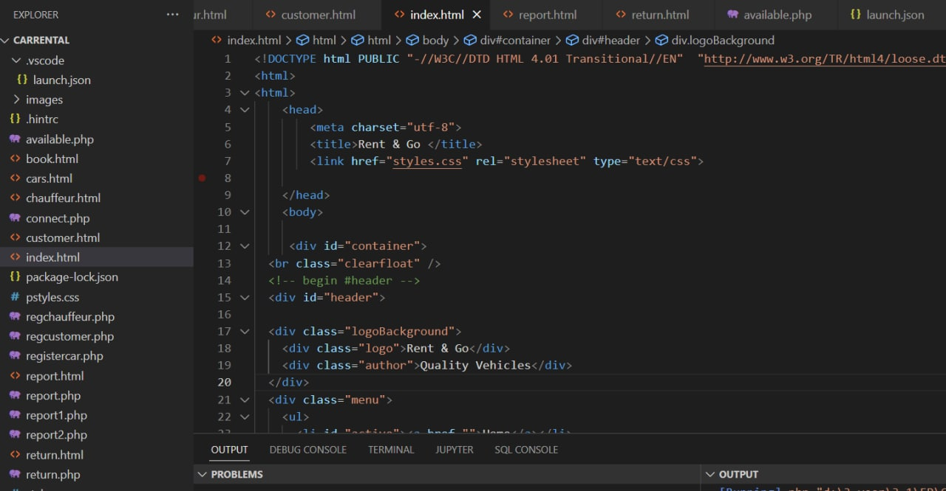

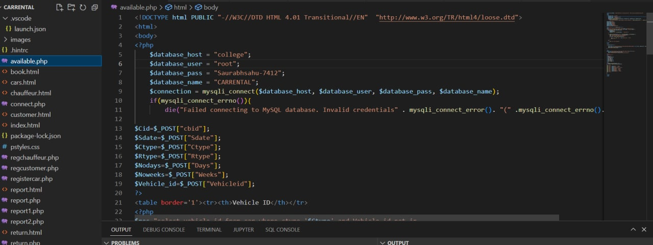

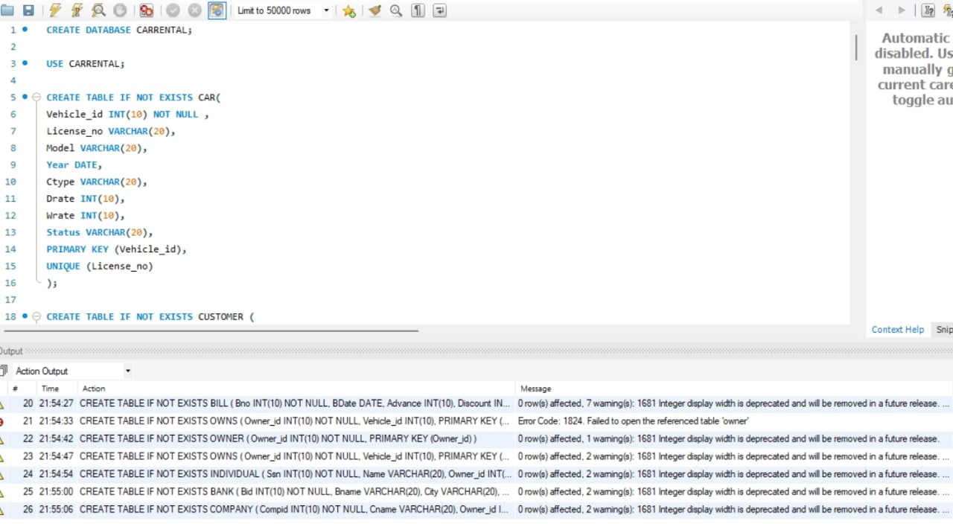

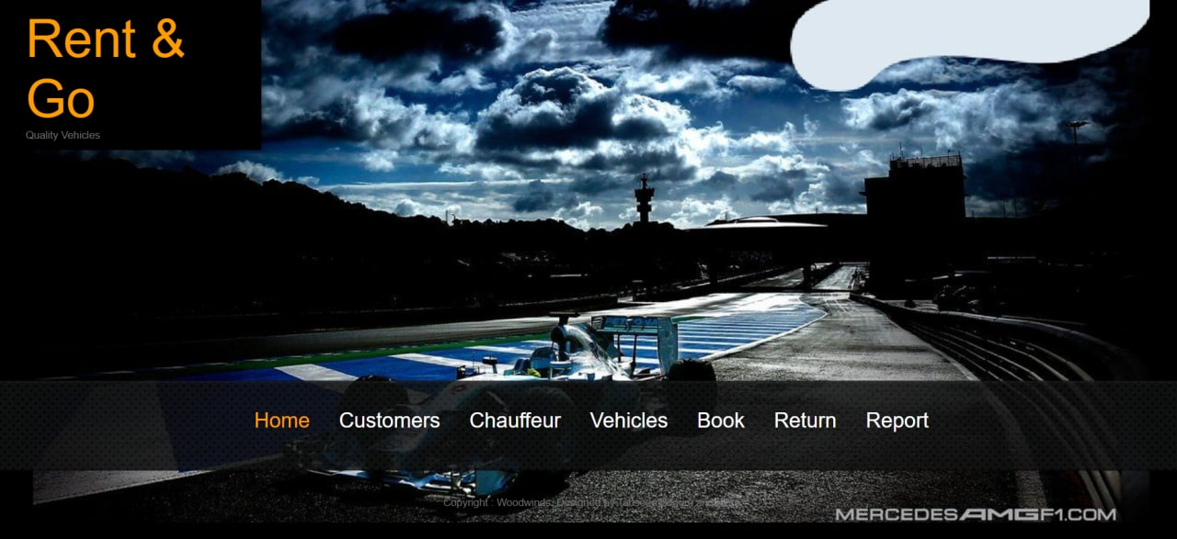

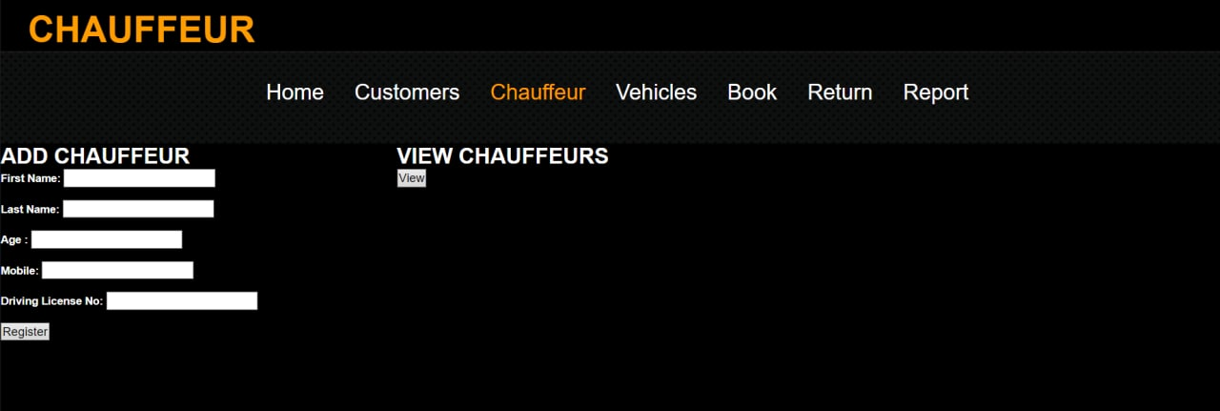 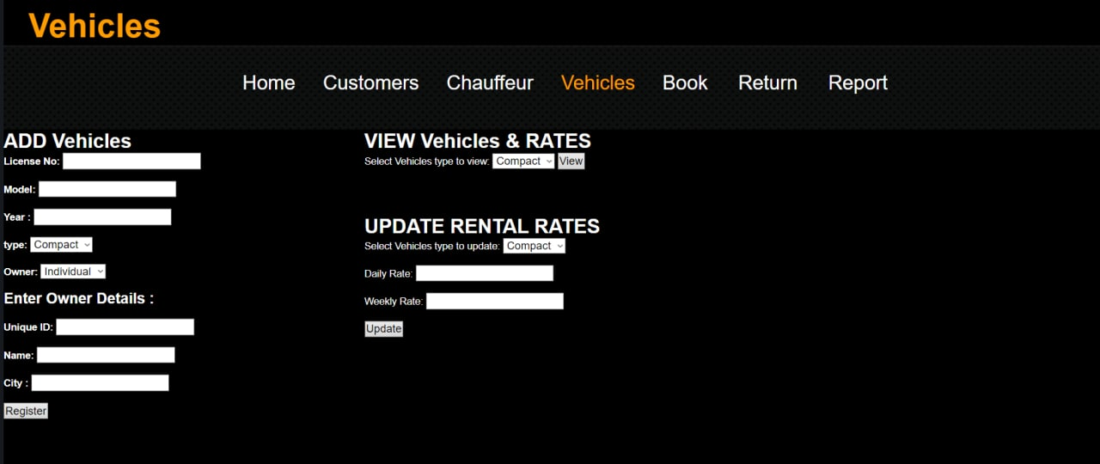

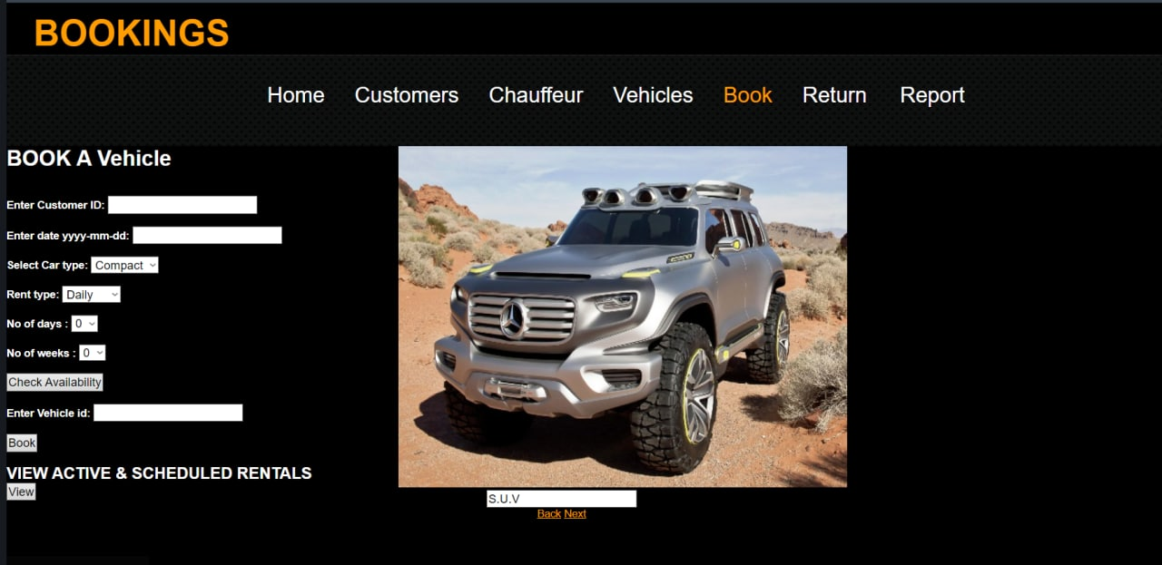

**5: CONCLUSION AND RECOMMENDATIONS**

5.1 CONCLUSION

Summarizing the above presentation, for the concept of renting cars and generating rental invoice of a rental company ,we have done a front end with a good user Summarizing the above presentation, for the concept of renting cars and generating rental invoice of a rental company ,we have done a front end with a good user interface using tools like eclipse ide and java web api.